**NALAIYA THIRAN**

**WEEK 3 REPORT**

**Phase 2 Description:** Ideation Phase (Literature Survey, Empathize, Defining Problem Statement, Ideation)

2.3 Prepare Empathy Map Canvas to capture the user Pains & Gains, Prepare list of problem statements

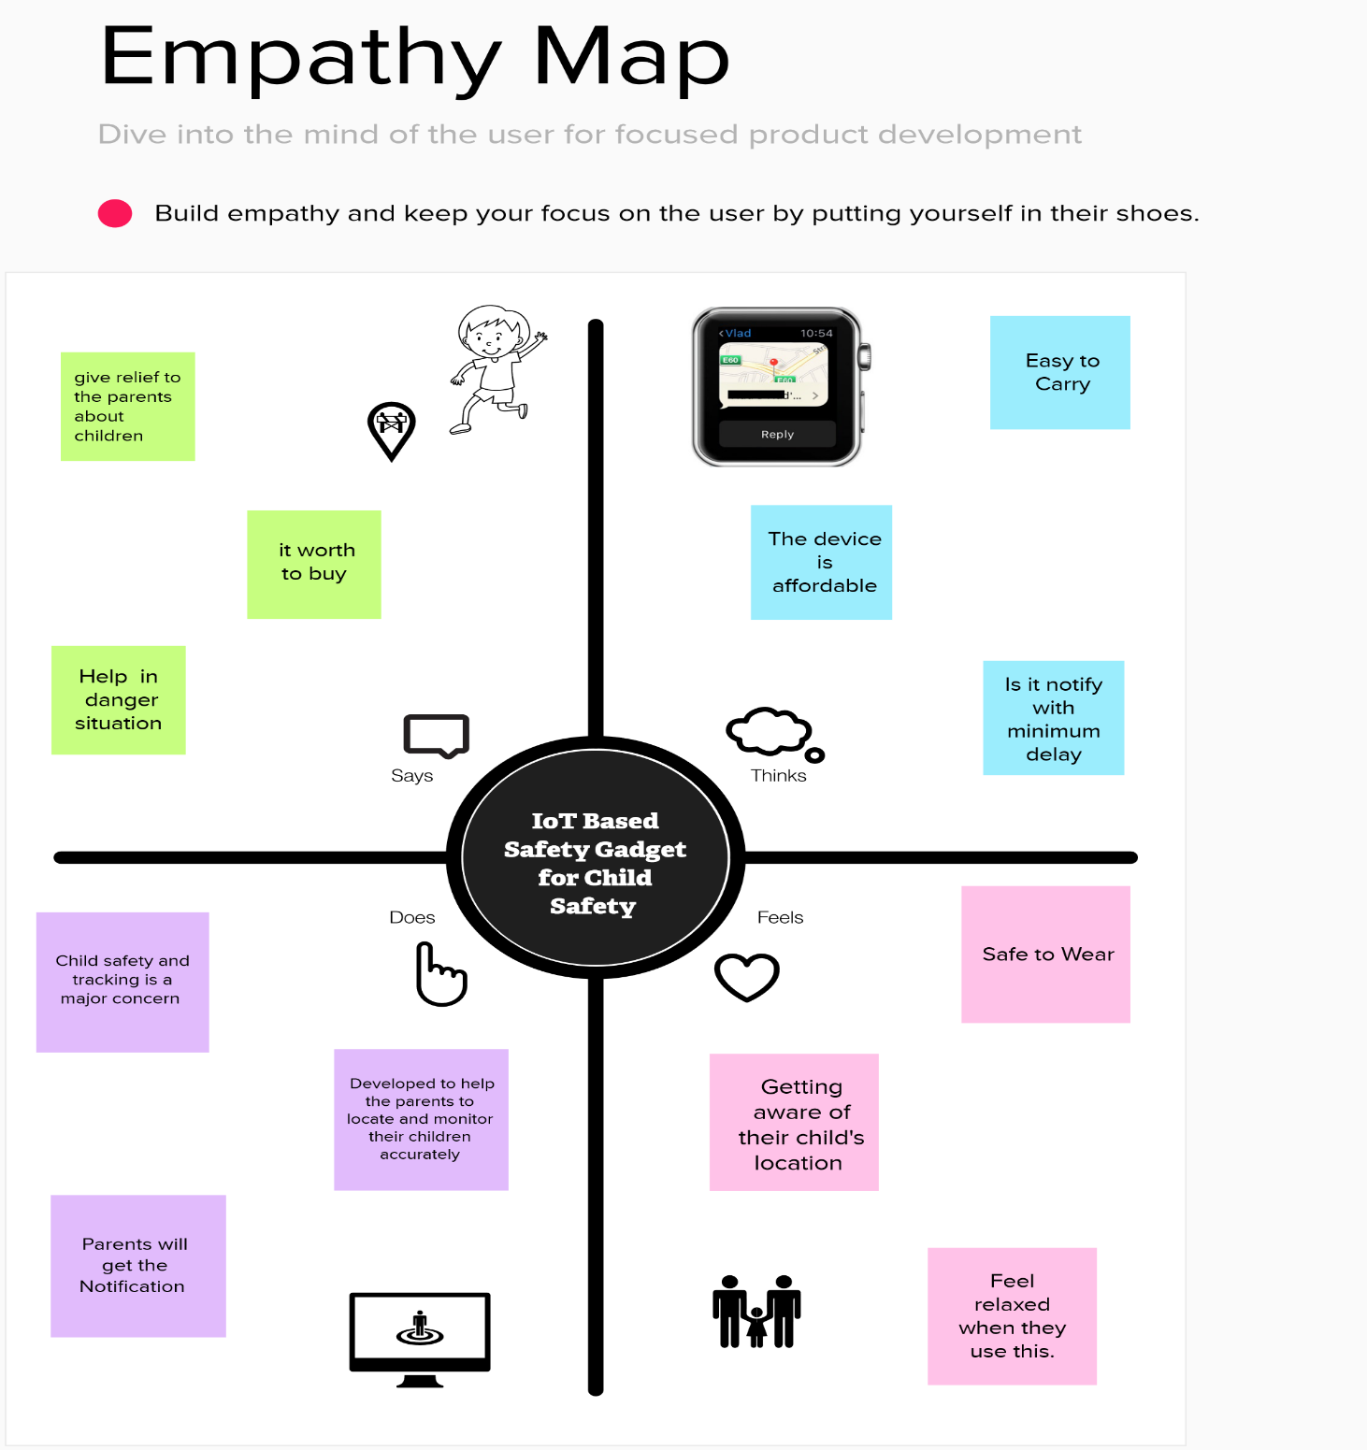

**PROBLEM STATEMENTS:**

* This paper describes a method for tracking school-age children's pick-up and drop-off times to improve their safety while travelling to and from school every day.
* Children are the foundation of a country; if their future was threatened, it would have an impact on the development of the whole country. In this world, a child goes missing every 40 seconds.
* As a result of the abuse, children lose their emotional and mental stability, which has a negative impact on their career and future.
* Parents are in charge of raising their own children. However, parents are compelled to want for money because of the state of the economy and their desire to concentrate on their child's future and job. Consequently, it becomes challenging for them to constantly cling to their kids.
* The system features a created web-based database-driven application that facilitates its operation and gives authorized staff relevant information about the kids.
* The development of a wearable gadget for women's and girls' protection and safety is the goal of this endeavor. By examining physiological signals in conjunction with bodily position, this goal is accomplished. The body temperature and galvanic skin resistance are the physiological signs that are examined.
* Wirelessly transferring sensor data to an open-source cloud platform enables real-time data monitoring. This equipment is set up to continuously track the subject's parameters and react to any potentially hazardous circumstances. It accomplishes this by noticing changes in the signals being tracked, after which the proper action is done by sending notifications or alerts to the right parties.
* With our system, we offer a setting where this issue can be solved effectively. It enables parents to keep an eye on their kids in real time without having to intervene manually, just as they were standing next to them.

2.4 Attended the technology trainings as per the training calendar

**IoT-B4-4M6E (Morning Session)-Day-3 (08.09.2022)**

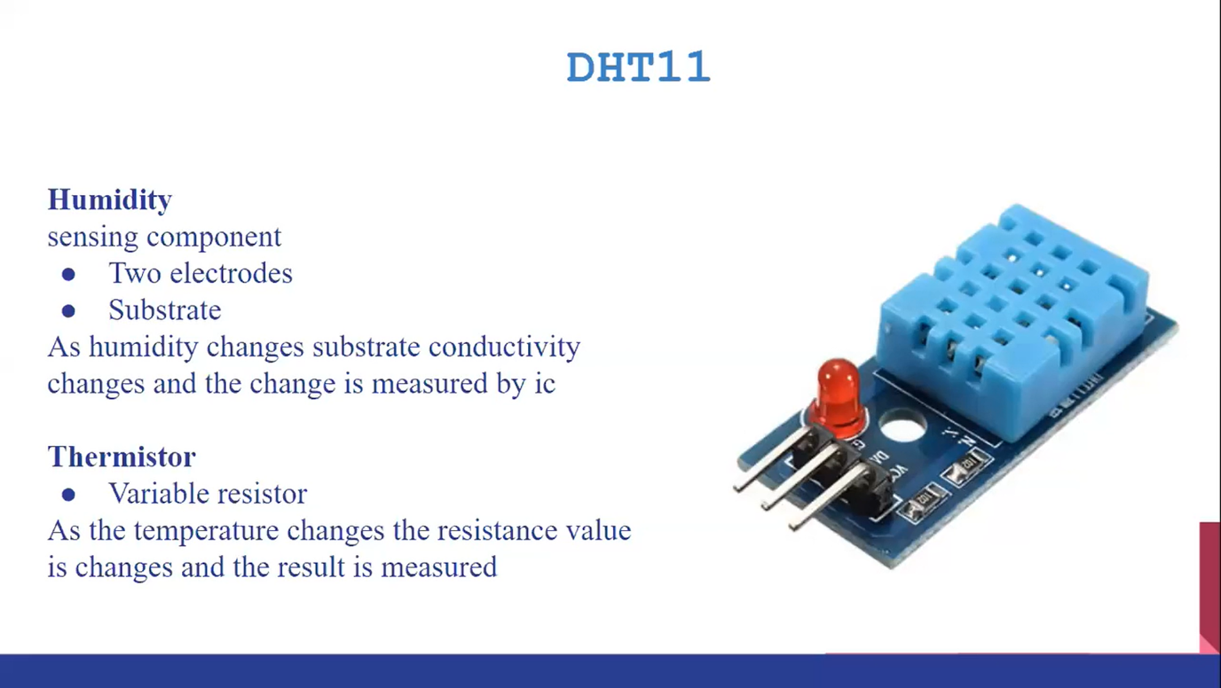

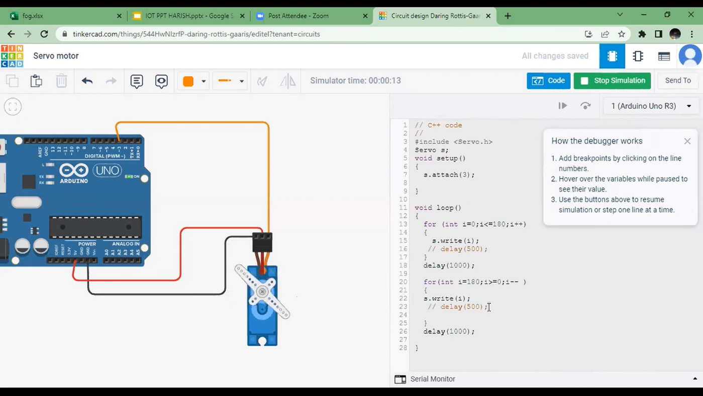

**IoT-B4-4M6E (Evening Session)-Day-4 (10.09.2022)**

